Financial Risk Management

Group Project

**SachsenLB Subprime CDO Losses (2007)**

**German bank's AAA-rated CDO investments wiped out by U.S. mortgage defaults.**

**Group 13**

**Group Members:** Killian Hanly: 21410142, Suhasini Satish Shegle: A00046077, Vikas Gupta: A00047802, Sangeetha Hariraman: A00046325, Roopan Chakravarthy Ganapathy: A00046253, Rohith Sivasekaran : A00013588

**Link for Presentation:**

<https://youtu.be/yrZQ-wgabMM>

**Word Count:** 3238 excluding cover pages, references, executive summary and appendix

Table of Contents

**Risk Identification4**

Defining Risk4

Identifying Risk6

**Quantitative Analysis8**

**Risk Mitigation Proposal12**

**References16**

**Appendix18**

**Executive Summaries18**

Killian Hanly18

Sangeetha Hariraman 18

Suhasini Satish Shegle 18

Vikas Gupta 18

Roopan Chakravarthy Ganapathy 18

Rohith Sivasekaran 19

Code for Quantitative Analysis19

**Introduction**

In 2007, SachsenLB, a German bank, invested in financial products called Collateralized Debt Obligations (CDOs), which were linked to U.S. home loans (mortgages). These investments were rated AAA, meaning they were supposed to be very safe.

However, many homeowners in the U.S. could not repay their loans, leading to a wave of mortgage defaults. This caused the value of CDOs to drop sharply, and SachsenLB suddenly faced huge losses. The bank ran out of money and had to be rescued by other German banks. Eventually, it was taken over by LBBW (Landesbank Baden-Württemberg) to avoid bankruptcy.

1. **Risk Identification**

**Defining Risk**

Risk is a word that has various meanings to various people depending upon their perceptions and different situations. Some of the definitions are based on probabilities, sectors (such as marketing, finance, engineering and others), others on expected values, some on uncertainty and others on objectives. The definition of risk has been given by various authors which has evolved from the year 1921. (Šotić & Rajić, 2015)

Definition of risk by ISO 31000 which is focused upon uncertainty and recognizes both positive and negative effects is recognised worldwide.

“Risk is the effect of uncertainty on objectives. “

ISO 31000 categorizes Risk in two types:

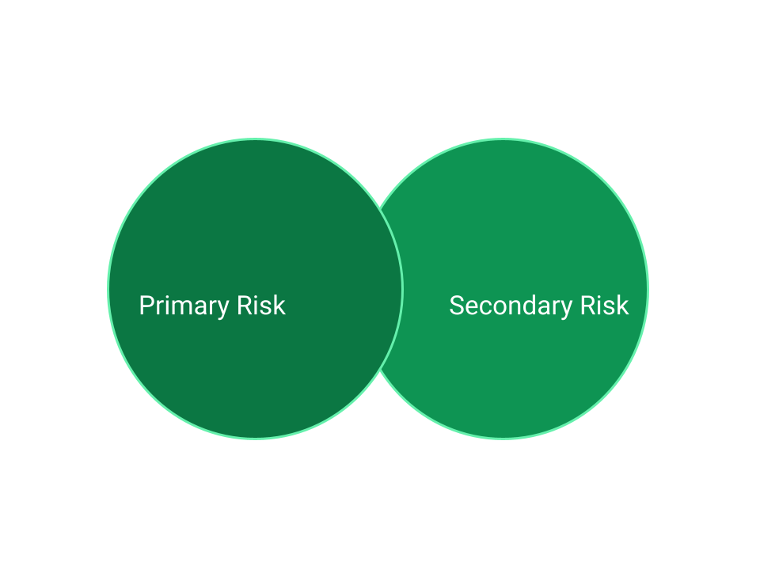

**Case Study - SachsenLB Subprime CDO Losses (2007) • German bank's AAA-rated CDO investments wiped out by U.S. mortgage defaults.**

**SachsenLB-** Sachsen Landesbank was a state-owned bank in Germany and was founded in 1992.

**CDO-** A collateralized debt obligation (CDO) is a type of [structured](https://en.wikipedia.org/wiki/Structured_finance) [asset-backed security](https://en.wikipedia.org/wiki/Asset-backed_security) (ABS).Originally developed as instruments for the corporate debt markets.

**Credit Rating-** A credit rating evaluates the credit worthiness of an issuer. Credit ratings are determined by credit ratings agencies. Here AAA means that it has the highest credit rating indicating minimal risk and an entity’s strong ability to meet its obligations while in the end CC has very low credit rating indicating maximum risk of entity being at default. (*Credit Rating Table – Wikirating*, 2020)

**Understanding the case:**

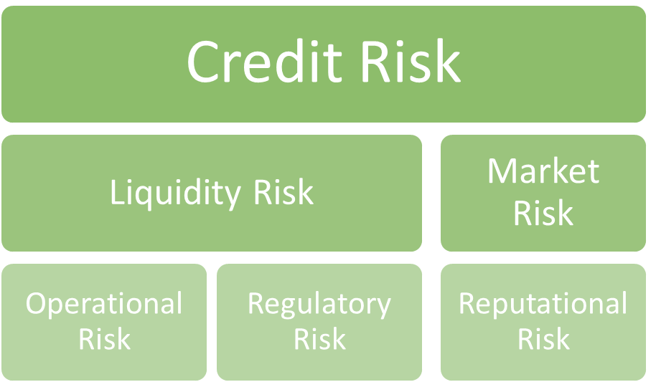**Types of Primary Risk that are associated with the given case.**

1. **Credit Risk**- SachsenLB had exposure to the market which made them invested in AAA-rated CDOs backed by subprime mortgages. In 2007 these mortgages defaulted due to the US housing market crash, then the value of these assets declined which led to massive losses for the bank.

Contributing Factors

* Overexposure to subprime CDOs.
* Focused on only one investment.
* Relied only on credit ratings i.e., AAA rating.

1. **Liquidity Risk-** SachsenLB invested all its money in long-term mortgages which made the bank unable to meet its short-term financial obligations due to insufficient cash.

Contributing Factors

* Poor liquidity management.
* Focused on long-term investments.

1. **Market Risk-** As the US housing market collapsed, it caused a sharp decline in value of subprime mortgage-backed securities by which SachsenLB faced huge Market loss.

Contributing Factors

* Inability towards hedging.
* Market Fluctuations.
* Lack of risk diversification.

1. **Operational Risk-** Due to poor internal risk management SachsenLB failed to recognize the dangers of its subprime mortgage investments. As it overly relied on credit rating the bank suffered heavy losses.

Contributing Factors

* Poor Internal Management.
* Relied solely on credit rating.

1. **Regulatory Risk-** SachsenLB ignored market laws and regulations and used state guarantees to secure cheap funding through ‘grandfathered debt’ which were removed in 2005 making it difficult for banks to raise the capital.

Contributing Factors

* Relied upon state guarantees.
* Ignored the laws and regulations.

1. **Reputational Risk-** SachsenLB tried to invest their time in preparing false news in press that Ormond Quay had strong refinancing support from investors but these statements were not true and hence, used as a misleading strategy. (Georgescu & Laux, 2013)

Contributing Factors

* Misleading public statements.
* Failure to maintain investor confidence.
* Sudden bailout after false assurances.

**Conclusion:**

The bank neglected the risks resulting in SachsenLB's downfall. This crisis is an eye-opener for other institutions and understanding the need for efficient risk management to ensure financial stability and transparency. Effective Risk management is the systematic process of identifying, assessing, and mitigating threats or uncertainties that can affect your organization. It involves analysing risks’ likelihood and impact, developing strategies to minimize harm, and monitoring measures’ effectiveness which improves institutions performance.

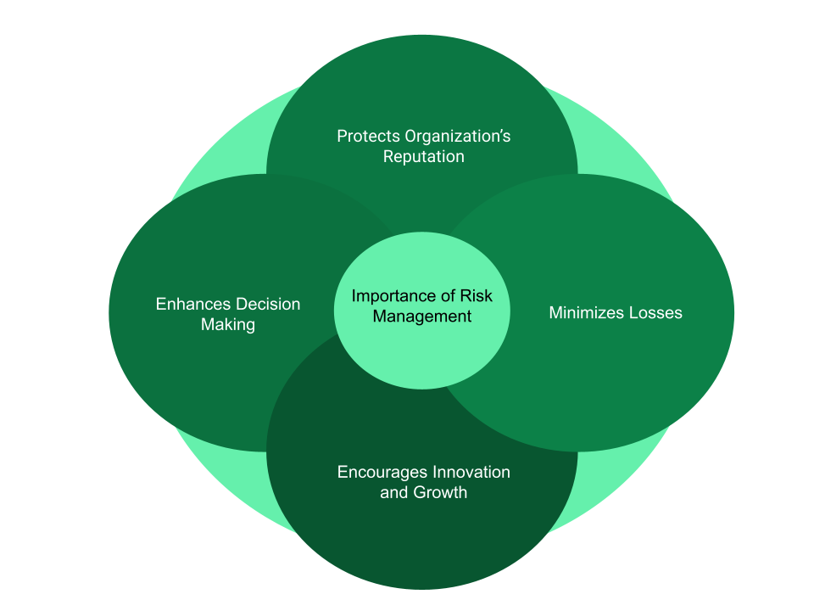

1. **Quantitative Analysis**

**Data**

Source:[https://eur-lex.europa.eu/legal content/EN/TXT/HTML/?from=DE&uri=CELEX%3A32009D0341&utm_source](https://eur-lex.europa.eu/legal%20content/EN/TXT/HTML/?from=DE&uri=CELEX%3A32009D0341&utm_source)

Financial data from Landesbank Sachsen (SachsenLB) during 2006 reveals necessary Information about bank capital allocation along with its funding stability and business risks. Key financial indicators include:

|  |  |
| --- | --- |
| **Total Assets** | €62.26b |
| **Total Liabilities** | €60.82b |
| **Tier 1 Capital** | €1.368 |
| **Debt-Equity Ratio** | 42.32 |

SachsenLB maintained €9.988 billion of assets maturing within three months when short-term debts amounted to €17.065 billion. The financial information reveals that SachsenLB depended heavily on short-term financing which exposed the bank to immediate funding risks.

**Impact of the 2007-08 Financial Crisis on SachsenLB**

SachsenLB entered the list of first German banks that experienced negative impacts from the US subprime mortgage crisis. The German banking regulator detected SachsenLB’s European Irish operating arm SachsenLB Europe plc was facing an upcoming cash flow deficit when it evaluated the bank in August 2007. Refinancing through Commercial Paper (CP) markets caused difficulties particularly for the bank’s largest conduit structure known as Ormond Quay.

This action prevented the bank from suffering an immediate failure of its liquidity.

During mid-August 2007 the Deka Bank and other Landesbanken joined forces to refinance operations. SachsenLB's total assets would face drastic deterioration if the bank underwent a forced asset divestment due to lack of intervention.

The loss-generating SachsenLB got incorporated into Landesbank Baden-Württemberg (LBBW) during the end of August 2007 because no viable recovery path emerged along with rising losses.

A protection agreement under risk shield terms from December 2007 between SachsenLB and LBBW led tosolvency guarantees while bringing SachsenLB under permanent LBBW control.

**1. Liquidity Position**

Liquidity Ratio: 0.59

The liquidity ratio shows that SachsenLB possessed 59 cents of liquid assets against each euro of its short-term debt. Because of its severe liquidity mismatch SachsenLB depended significantly on fast-maturing funding sources for fulfilling its debt obligations. Conditions deteriorating in the market prevented funding sources from remaining available which resulted in a liquidity crisis for the institution.

**2. Capital Adequacy**

Tier 1 Capital Ratio: 8.20%

Tier 1 Capital Ratio: 8.20% Financial core strength at banks is quantified through the Tier 1 capital ratio calculation. The 8.20% capital ratio of SachsenLB exceeds industry requirements but it remains insufficient to manage substantial losses which could happen during periods of financial instability. The institution's low capital level required outside government intervention through an emergency bailout.

**3.Market Risk – Value at Risk (VaR) and Expected Shortfall (ES)**

Value at Risk (VaR) thresholds appear in the histogram of SachsenLB’s daily log returns which shows the risk profile.

• VaR at 95% Confidence: -0.0249 (-2.49%)

SachsenLB would maintain its investment value above 2.49% loss during 95 out of every 100 business days. Extreme cases among the worst five percent of days (5%) would result in losses beyond the calculated figures.

• Expected Shortfall (ES) at 95% Confidence: -0.0309 (-3.09%)

Expected shortfall (Conditional VaR) provides a calculation of average losses exceeding VaR by revealing the genuine tail risk. The 3.09% expected loss figure from SachsenLB indicates that daily losses would be large when they surpass VaR thresholds.

• VaR at 99% Confidence: -0.0332 (-3.32%)

Extreme market conditions have a probability of 1% to produce such daily losses which exceed 3.32%.

• Expected Shortfall (ES) at 99% Confidence: -0.0394 (-3.94%)

SachsenLB faces major downside risk as its average daily loss will reach 3.94% when losses surpass the VaR threshold at 99% confidence.

**Credit VaR**

Due to the nature of the products on SachsenLB’s balance sheet it was necessary to calculate credit VaR to fully assess the position it was in. The figures needed for this calculation came from a variety of papers that looked back and assessed the crisis as a whole and some that looked particularly at SachsenLB. The exposure numbers came from Senkarcin (2021) and the more general figures probability of default, LGD etc came from Barnett-Hart (2009).

Expected Loss (EL): €4,080,000,000.00

Unexpected Loss (UL): €11,624,665,121.44

Credit VaR at 99.0% confidence: €15,704,665,121.44

The exceedingly high unexpected loss and very high credit VaR illustrates how difficult a situation Sachsen LB found itself and eventually led to it being taken over by LBBW,

**4. Risk Implications and Collapse**

The inability of SachsenLB to roll over their short-term commercial paper created an urgent funds shortage. The insufficient capital reserves made SachsenLB incapable of handling growing losses effectively. The downside financial risk exposure of SachsenLB becomes particularly severe based on computed VaR and ES values since extreme market conditions make the entity highly prone to financial shocks.

**Conclusion**

This analysis verifies that SachsenLB found itself in trouble due to its inadequate risk protection measures which combined with an immediate funding shortage. Its bailout combined with its integration into Landesbank Baden-Württemberg (LBBW) occurred because of its high leverage ratio, poor liquidity position and extreme tail risk exposure. The situation shows how banking institutions require improved liquidity management along with sufficient capital reserves and powerful risk controls to maintain business operations.

**3. Risk Mitigation Proposal**

**1. Strengthening Risk Governance**

**Issues Identified:**

The governance scheme of SachsenLB completely failed to provide sufficient oversight over important investment decisions involving high risks. The entire board was unable either to prevent or monitor exposure by the bank to subprime CDOs. Not the least also risk management functions were properly independent of the revenue-generating investment teams. Generally, conflicts of interest have been caused by this great separation because of investment strategies being focused on short-term performance instead of longer-term health.

**Proposed Measures:**

SachsenLB should have had an independent Risk Management Committee, with board-level representation to avoid such governance failures. The committee would have had the primary purpose of oversight over risk exposure, evaluation of investment proposals for higher risks, and compliance with regulatory guidelines. Also, such board approval for investment in complex or high-risk instruments would have increased the level of scrutiny which makes it more difficult for risky investments to remain out. Lastly, clear separation between risk oversight and trading/investment teams would take away conflicts of interest and ensure independent and objective risk as well as management assessments.

**2. Improved Due Diligence on Structured Products**

**Issues Identified:**

SachsenLB made use of rating agencies to judge the structured financial products' risk without making an internal assessment of the risk. The complexities of collateralized debt obligations (CDOs) made it harder to grasp the risks hidden in them and led to unforeseen financial damages caused by increased subprime mortgage defaults.

**Proposed Measures:**

In such circumstances, SachsenLB should subject each structured product to rigorous internal credit analysis prior to investment decision-making. For example, rather than blindly relying on external ratings, the bank could have developed its model to assess the risk profile of each asset. Stress testing against worst-case scenarios-also housing market collapse, interest rate spikes, liquidity freezes-would enhance the understanding of the potential downside risks of the portfolio. Finally, SachsenLB should have either banned or grossly limited investments in opaque or non-transparent financial structures: that is, keep only assets with clear risk parameters in its portfolio.

**3. Exposure Limits and Portfolio Diversification**

**Issues Identified:**

SachsenLB's investment strategy suffered from concentration risk due to its heavy investment in U.S. subprime mortgage-backed securities; thus, it was overtly susceptible to downturns in the housing market. With this lack of diversification, Sachsen was left with no other asset class to help offset its losses when the subprime crisis enveloped it, with the result that they fell into major financial trouble.

**Proposed Measures:**

To mitigate concentration risk, SachsenLB could have imposed exposure limits on asset classes and regions, thereby fulfilling the stipulation of diversification in their investment portfolios. Limiting exposure to any one sector, such as subprime mortgage securities, would preclude excessive risk-taking in a single market. Moreover, a diversification requirement for investments across industries, credit ratings, and geographic regions should have been instituted as a matter of policy by the bank. This would have diminished the effects that one bad market might have on the overall financial well-being of the bank. Finally, correlation risk assessments would have aided SachsenLB in understanding how different investments got connected and learning not to put all eggs in one basket.

**4. Liquidity Risk Management**

**Issues Identified:**

Problems Identified: SachsenLB had a serious liquidity issue as it financed long-term investments in CDOs via short-term funding through the Ormond Quay conduit. When the ABCP market collapsed, it had no measures to cope with sudden liquidity shortfall and was forced to look for emergency liquidity support from German state banks to the tune of €17.3 billion.

**Proposed Measures:**

SachsenLB must develop a proper liquidity risk framework, outlining clearly liquidity buffers and early warning indicators, to avoid sudden liquidity crises. Such key indicators should have been in place to look for early signs of funding vulnerabilities before such vulnerabilities translated themselves into full-blown crises. In addition, cash flow projection and funding gap analysis give important indicators of the liquidity position of the bank to cope with any unforeseen events. Emergency credit lines with counterparties and central banks should have been assured in order to provide alternative funding means and avoid exposure to volatile short-term debt markets.

**5. Establish a Comprehensive Risk Management Framework**  
The purpose of a full risk management framework is to encompass all aspects of identifying, assessing, and mitigating risks in decision-making. In a nutshell, the bank must implement a standardized formal Enterprise Risk Management (ERM) system that aligns with ISO 31000 standards, which ensures a systematic approach to managing risks within an organization concerning financial risk and its consistent assessment and addressing within the organization.

**Justification:**

This comprehensive ERM system would help SachsenLB in managing the entire life cycle risks, proactively, not reactively, when something has "blown up." With ISO 31000 in place, a clear methodology would help the bank in identifying, assessing, and mitigating risks emanating from complex investments like CDOs. By embedding risk management into operational daily works, this bank will better stand in market downfall and "early catches" any potential risks that could cause major financial fallout.

**Real-world Example:** **SachsenLB (2007)**

A major reason for the financial calamity was the nonexistence of a comprehensive and independent risk management framework in SachsenLB. The bank was dependent on outside credit ratings without conducting its own internal risk assessments and incurred massive losses from its investments in subprime CDOs. Had SachsenLB introduced a robust Enterprise Risk Management (ERM) system in accordance with international standards such as ISO 31000, the bank would have had a structured approach to assess, monitor, and mitigate risks more effectively. A stronger risk management system could have recognized potential risks of such securities and the impact on the U.S. housing market failure.

**6. Develop a Diversified Investment Strategy**  
The purpose of diversification is to ward off concentrations in risky asset classes like subprime CDOs, which set up the bank for serious losses. To this effect, SachsenLB should have formulated, codified, and strictly adhered to an asset allocation policy that stressed diversification across sectors, geography, and risk profiles. This method would allow for a portfolio that would not be overly concentrated in any particular asset class or market while sharing this risk across others.

**Justification:**

Diversification is an instrument for concentration risk reduction and financial stability. Had SachsenLB pursued a diverse investment strategy rather than heavily investing in subprime mortgage-backed securities, it would have been less susceptible to the strains of a crumbling market. The bank would have been protected from significant losses in the event of a downturn in any one sector, so it effectively distributed its risk across various industries and regions.

**Real-world Example:** **SachsenLB (2007)**

The enormous exposure of the bank to subprime mortgage-backed CDOs was its death knell when the U.S. housing market collapsed. SachsenLB was weakened by its inability to diversify its investments across different sectors and asset classes, leaving it very vulnerable to a single market risk. Other banks pursuing a diversified investment strategy and spreading their investments across a range of asset classes, regions, and industries would have survived the downturn in a much healthier state. Deutsche Bank, by selecting a diversified investment portfolio across sectors, mitigated much of the exposure to the housing market and thus afforded stability during the crisis.

**7. Strengthen Liquidity Management Policies**  
The aim in strengthening liquidity management policies is to ensure that the bank is in a position to meet its short-term obligations even when financial stress occurs. For this, SachsenLB should keep liquidity buffers on hand, conduct liquidity stress tests regularly, and closely monitor important indicators such as the liquidity coverage ratio (LCR). This will enable the bank to identify potential liquidity gaps early on and act to prevent that lapse into a liquidity crisis.

**Justification:** A liquidity mismatch at SachsenLB in which short-term funding was used for long-term investments exposed the bank to sudden market disruptions. Maintaining liquidity buffers and stress-testing would have ensured that the bank possessed liquid assets to meet obligations in times of financial stress. Continuous monitoring of the LCR would provide insight into the liquidity position of the bank so that intervention could take place before the onset of a liquidity shortfall, thus preventing further damage in periods of market distress.

**Real-world Example: SachsenLB (2007)**

SachsenLB confronted a liquidity crisis, having funded long-term investments in subprime CDOs reliant on very short-term funding. Once these investments devalued, the bank's incapacity to settle its short-term obligations only added to its financial troubles. Maintaining liquidity buffers while performing stress tests showed their importance. Deutsche Bank had low levels of disruption during that time with far more stringent policies on liquidity management. Because of that, Deutsche Bank had enough liquidity buffers along with possible stress-testing scenarios to take care of its short-term obligations and avert a liquidity crisis in this timeframe.

**8. Enhance Internal Controls and Risk Governance**  
The purpose of enhancing internal controls and risk governance is to minimize operational risk and ensure that risks are adequately managed throughout the entire organization. So to achieve that, SachsenLB should form independent risk and audit committees, improve segregation of duties, and engage in continuous staff training in risk management practices. These would improve oversight of risk management activities and strengthen the accountability chain within the organization.

**Justification:** Internal controls and governance structures are necessary to identify risks and mitigate them in a timely manner. The incidents that occurred within SachsenLB were allowed to materialize because of a lack of proper internal oversight, thereby placing the bank at excessive risk and then triggering its demise. Independent risk and audit committees would have guaranteed proper oversight over risk management processes. Duty segregation, combined with ongoing staff training, would have also reassured timely detection and management of risk and reduced the likelihood of human error and fraud.

**Real-world Example: SachsenLB (2007)**

The defining characteristic of the demise of SachsenLB was the weakness of internal control and governance. There was not enough oversight of risky investing decisions, and risk management was not sufficiently independent of the revenue-generating units. This failure to keep risk management from business objectives put the bank in a very high-risk environment in terms of CDOs. Therefore, a more solid internal control system and governance structure, as with HSBC, would ultimately help. After previous compliance problems, HSBC created independent risk management committees and stepped-up internal audits and controls, something that might as well have helped SachsenLB in the first place to manage and contain risks aside from internal weaknesses.

**References**

Acharya, V. V., & Richardson, M. (2009). Restoring Financial Stability: How to Repair a Failed System. Wiley Finance.

**Administrative Expenses:** The bank reduced administrative expenses by 10.9% in the first half of 2006 compared to the previous year, totaling €57.8 million.: <https://vb.is/eftir-vinnu/sachsen-lb-presents-hy1-figures/?utm_source>

**Balance Sheet Total:** In 2006, SachsenLB reported a group balance-sheet total of €67.8 billion, with own capital amounting to €880 million: <https://eur-lex.europa.eu/legal-content/EN/TXT/HTML/?from=DE&uri=CELEX%3A32009D0341&utm_source>

Basel Committee on Banking Supervision. (2011). Basel III: A global regulatory framework for more resilient banks and banking systems. Bank for International Settlements.

Credit Rating Table – Wikirating. (2020). Retrieved March 23, 2025, from Wikirating.com website: <https://www.wikirating.com/help/credit-rating-table/>

FCIC. (2011). The Financial Crisis Inquiry Report. Final Report of the National Commission on the Causes of the Financial and Economic Crisis in the United States.

**Financial Market Services Exposure:** Approximately 70% of SachsenLB's balance sheet was dedicated to financial market services, indicating significant exposure to market fluctuations: <https://ec.europa.eu/competition/state_aid/cases/224576/224576_791168_24_1.pdf?utm_source>

Financial Stability Board. (2009). Report of the Financial Stability Forum on Addressing Procyclicality in the Financial System.

**For calculation of liquidity ratio: European Commission:** (Limited Access)<https://ec.europa.eu/competition/state_aid/cases/224576/224576_791168_24_1.pdf?utm_source>

Georgescu, O. M., & Laux, C. (2013). Financial Reporting, Financial Regulation, and Financial Stability: Evidence from German Bank Failures in 2007-2008. SSRN Electronic Journal. <https://doi.org/10.2139/ssrn.2238421>

International Organization for Standardization. (2018). ISO 31000:2018 Risk management – Guidelines.

Jorion, P. (2007). Value at Risk: The New Benchmark for Managing Financial Risk (3rd ed.). McGraw-Hill.

Laeven, L., & Valencia, F. (2010). Resolution of Banking Crises: The Good, the Bad, and the Ugly. IMF Working Paper.

Šotić, A., & Rajić, R. (2015). Online Journal of Applied Knowledge Management The Review of the Definition of Risk. Retrieved from <https://www.iiakm.org/ojakm/articles/2015/volume3_3/OJAKM_Volume3_3pp17-26.pdf>

**The Financial Data of Sachsen LB in the research Report- “Financial Reporting, Financial Regulation, and Financial Stability: Evidence from German Bank Failures in 2007-2008”-Date: February 2013** <https://www.researchgate.net/publication/256054569_Financial_Reporting_Financial_Regulation_and_Financial_Stability_Evidence_from_German_Bank_Failures_in_2007-2008>

to, C. (2023, December 22). component of Germany’s banking sector. Retrieved March 23, 2025, from Wikipedia.org website: <https://en.wikipedia.org/wiki/German_public_banking_sector?utm_source=chatgpt.com>

Turner Review. (2009). A regulatory response to the global banking crisis. Financial Services Authority.

What Is Risk Management & Why Is It Important? | HBS Online. (2023, October 24). Retrieved March 23, 2025, from Business Insights Blog website: <https://online.hbs.edu/blog/post/risk-management>

**Appendix**

**Executive Summaries**

**Killian Hanly 21410142**

My contribution to this paper was working on the quantitative analysis section along with Suhasini, I searched for the relevant figures across the literature and then used python to calculate credit specific risk metrics to reflect the credit products held on Sachsen LB’s books in 2007. I also put the paper together, taking all of my group member’s work and proofreading it and combining it, I also designed the PowerPoint and was responsible for recording the presentation.

**Sangeetha Hariraman: A00046325**

I completed the risk mitigation section where, I assessed reasonable measures addressing SachsenLB risks during the 2007 crisis. These included establishing the independent Risk Management Committee for risk governance, strengthening due diligence concerning structured products, threatening exposure limits regarding portfolio diversification, and stronger liquidity. I also suggested that implementing a comprehensive Enterprise Risk Management (ERM) framework and stressing the need for better internal control mechanisms able to pro-actively identify and mitigate risks would prevent similar occurrences. Thus, this would discourage excessive risk-taking, strengthen financial stability, and protect against future financial crises

**Suhasini Satish Shegle- A00046077**

My analysis consisted of evaluating SachsenLB's financial risk, focusing on both liquidity and market risk, as well as capital adequacy measures. The analysis included ratio calculations such as a liquidity ratio and Tier 1 capital ratio, followed by the implementation of Python-based Value at Risk (VaR) and Expected Shortfall (ES) risk assessment models.

**Vikas Gupta A00047802**

As per my contribution in the assignment I got to understand the case of SachsenLB bank and its contribution to the financial crisis in 2007. I also analyzed the primary risks that were associated with SachsenLB's downfall.

SachsenLB was a state-owned German bank that heavily relied on AAA rated collateralized Debt Obligations (CDOs) which were linked to U.S. subprime mortgages. It was a time when the US housing market collapsed, and lenders were not able to repay their loans leading to mortgage defaults. SachsenLB faced credit, liquidity, market, operational, regulatory and reputational risks, leading to financial distress and a forced takeover by LBBW bank.

**Roopan Chakravarthy Ganapathy:A00046253**

My part focused on the major shortcomings that led to the downfall of SachsenLB: there was no independent governance of risk, there was inadequate due diligence with respect to structured products, and there was concentration in subprime assets. Risk mitigation would have suggested that high liquidity buffers be put in place, forecasting of cash flow under the policies be done regularly, and diversification in terms of sectors, geographical regions, and ratings be embarked upon. In conclusion, I held that the crisis in the SachsenLB was preventable with proper risk governance, foresight, and transparency and went on to advocate the establishment of a holistic risk management framework that would ensure financial resilience in a rapidly changing marketplace.

**Rohith Sivasekaran A00013588**

My contribution has focused on creating a strong framework for continuous risk-monitoring and internal/external communication aimed at preventing potential crises, such as the one faced by SachsenLB. I suggested real-time risk dashboards, stress testing, and early-warning indicators, which, together, allow for the current detection of exposure to high-risk assets. Said communication should stress transparency inwards and outwards regarding regulators to promote accountability while ensuring timely decision. Hence, the present proactive monitoring and dialogue set in motion serve as an important risk management line of defense given that it also stands the organization in good stead to plan for, react to, and recover from adverse financial shocks.

**Code 1- Killian Hanly**

1. 1. #import library

2. import numpy as np

3. from scipy.stats import norm

4.

5. #Sachsen LB Credit Portfolio Parameters

6.

7. #Set confidence level

8. confidence_level = 0.99

9.

10. #Total Exposure from Balance sheet

11. exposure = 17_000_000_000

12.

13. #PD from Literature

14. prob_default = 0.40

15.

16. #LGD also from literature

17. loss_given_default = 0.60

18.

19. #Corr from literature

20. corr_factor = 0.2

21.

22. #z-score for confidence level

23. z_score = norm.ppf(confidence_level)

24.

25. #Expected Loss (EL)

26. expected_loss = exposure * prob_default * loss_given_default

27.

28. # Compute Unexpected Loss using CreditMetrics approach

29. unexpected_loss = exposure * loss_given_default * np.sqrt(prob_default * (1 - prob_default)) * z_score

30.

31. # Total Credit VaR

32. credit_var = expected_loss + unexpected_loss

33.

34. # Display results

35. print(f"Expected Loss (EL): €{expected_loss:,.2f}")

36. print(f"Unexpected Loss (UL): €{unexpected_loss:,.2f}")

37. print(f"Credit VaR at {confidence_level*100}% confidence: €{credit_var:,.2f}")

38.

1.  import matplotlib.pyplot as plt.

# Example Precomputed Credit VaR Data (Replace with actual values)

2. company_name = "Sachsen LB (2007)"

3. confidence_level = 0.99 # 99% confidence

4. credit_var = 11_624_665_121 # Precomputed Credit VaR (e.g., €8.5B)

5. expected_loss = 4_080_000_000 # Expected Loss (EL)

6. unexpected_loss = credit_var - expected_loss # Unexpected Loss (UL)

7.

8. # Simulating a Loss Distribution for Visualization

9. x = np.linspace(0, credit_var * 1.2, 1000) # Loss values up to 120% of Credit VaR

10. pdf = norm.pdf(x, loc=expected_loss, scale=unexpected_loss / 2) # Normal approx.

11.

12. # Plot Credit VaR Distribution

13. plt.figure(figsize=(10, 5))

14. plt.fill_between(x, pdf, where=(x <= credit_var), color='blue', alpha=0.5, label="Expected Loss")

15. plt.fill_between(x, pdf, where=(x > expected_loss) & (x <= credit_var), color='red', alpha=0.5, label="Unexpected Loss")

16. plt.axvline(credit_var, color='black', linestyle="dashed", linewidth=2, label=f"Credit VaR (€{credit_var/1e9:.2f}B)")

17.

18. # Labels & Title

19. plt.title(f"Credit VaR Distribution for {company_name}")

20. plt.xlabel("Potential Loss (€)")

21. plt.ylabel("Probability Density")

22. plt.legend()

23. plt.grid()

24.

25. # Show Plot

26. plt.show()

27.

**Code 2-Suhasini Satish Shegle**

1. 1.  import numpy as np

2. import matplotlib.pyplot as plt

3.

4. # **1. Real Financial Data from SachsenLB's 2006 Report**

5. assets_maturing_3m = 9.988 # in billion €

6. liabilities_maturing_3m = 17.065 # in billion €

7. tier_1_capital = 1.368 # in billion €

8. risk_weighted_assets = 16.692 # in billion €

9. debt_equity_ratio = 42.32 # Given in the report

10.

11. # **2. Calculate Liquidity Ratio**

12. liquidity_ratio = assets_maturing_3m / liabilities_maturing_3m

13. print(f"Liquidity Ratio: {liquidity_ratio:.2f}")

14.

15. # **3. Calculate Tier 1 Capital Ratio**

16. tier_1_capital_ratio = (tier_1_capital / risk_weighted_assets) * 100

17. print(f"Tier 1 Capital Ratio: {tier_1_capital_ratio:.2f}%")

18.

19. # **4. Simulated Log Returns (Replace with real data if available)**

20. np.random.seed(42)

21. log_returns = np.random.normal(loc=-0.002, scale=0.015, size=1000) # Adjusted for crisis impact

22.

23. # **5. VaR and Expected Shortfall (ES) Calculation**

24. confidence_levels = [0.95, 0.99]

25. VaRs = [np.percentile(log_returns, (1 - cl) * 100) for cl in confidence_levels]

26. ES = [log_returns[log_returns <= VaR].mean() for VaR in VaRs]

27.

28. # Print VaR & ES Results

29. for cl, VaR, es in zip(confidence_levels, VaRs, ES):

30. print(f"VaR at {cl*100:.0f}% Confidence: {VaR:.4f}")

31. print(f"Expected Shortfall (ES) at {cl*100:.0f}% Confidence: {es:.4f}")

32.

33. # **6. Plot Distribution of Log Returns with VaR Lines**

34. plt.figure(figsize=(10, 6))

35. plt.hist(log_returns, bins=50, density=True, alpha=0.6, color='g', label='Daily Returns')

36. for cl, VaR in zip(confidence_levels, VaRs):

37. plt.axvline(x=VaR, linestyle='--', label=f'VaR at {cl*100:.0f}% Confidence')

38. plt.xlabel('Daily Log Return')

39. plt.ylabel('Frequency')

40. plt.title('Distribution of SachsenLB Daily Log Returns with VaR')

41. plt.legend()

42. plt.show()

43.